User guide for our product (Ariv)
Our platform lets you build, test, and build, test, and optimize chatbots the smart way not just guess what might be good.
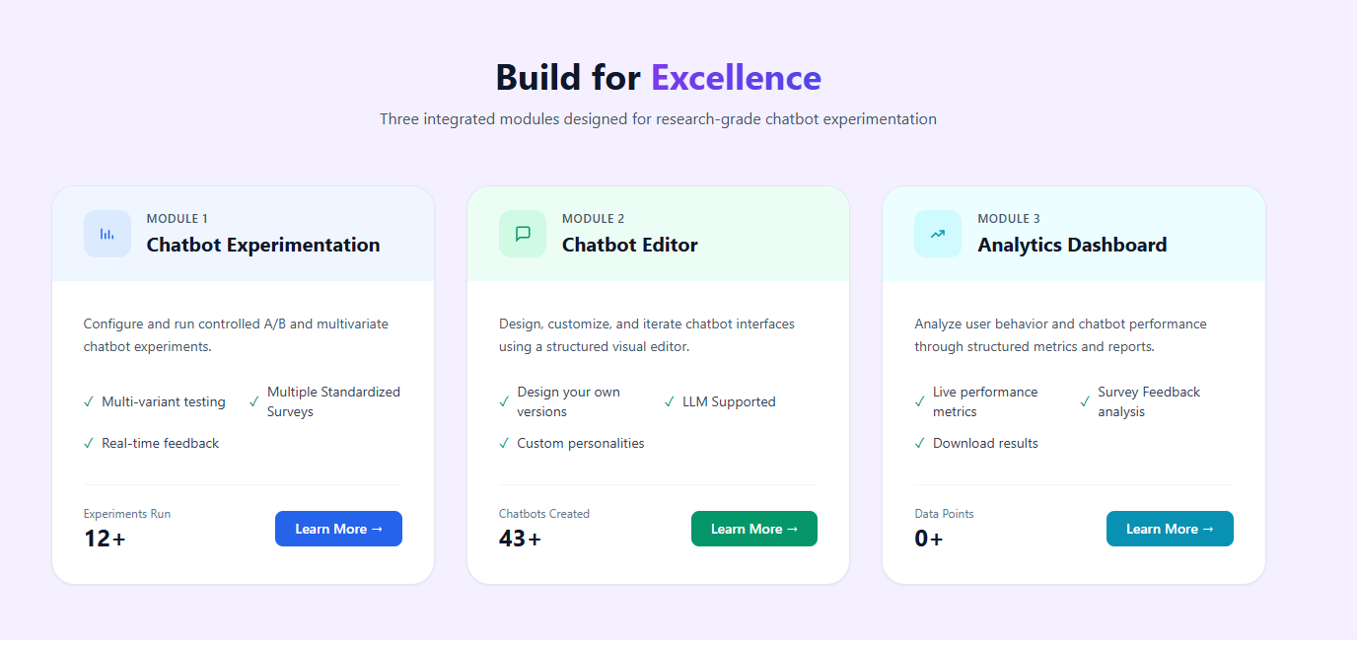
We built three connected pieces that cover everything from idea to results:
- Chatbot Experimentation - Conduct A/B tests
- Chatbot Editor – Customize your chatbot designs and behavior
- Analytics Dashboard - See clear results, compare versions, and spot what works best

- Chatbot Experimentation (General)
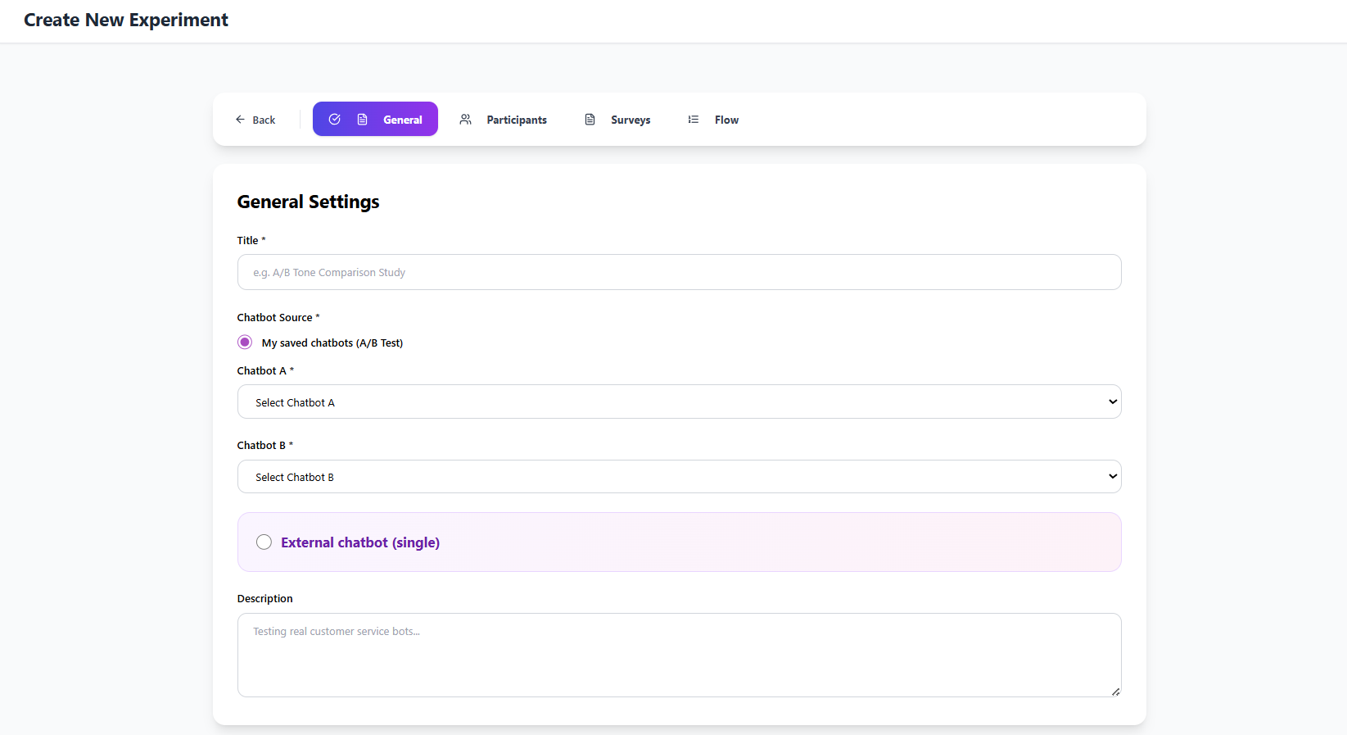

This is the General section in Chatbot Experimentation where you set up the basic structure of your test. Provide a clear title for the experiment, choose whether to use your saved chatbots or an external one, select Chatbot A (the main/control version) and Chatbot B (the variant to compare), and add a short description of what you are testing and why. Once these are filled, move to the next tabs to define participants, surveys, and flow.

  - Chatbot Experimentation (Participants)
This is the Participants section in Chatbot Experimentation where you control who takes part in your test and how they are assigned.

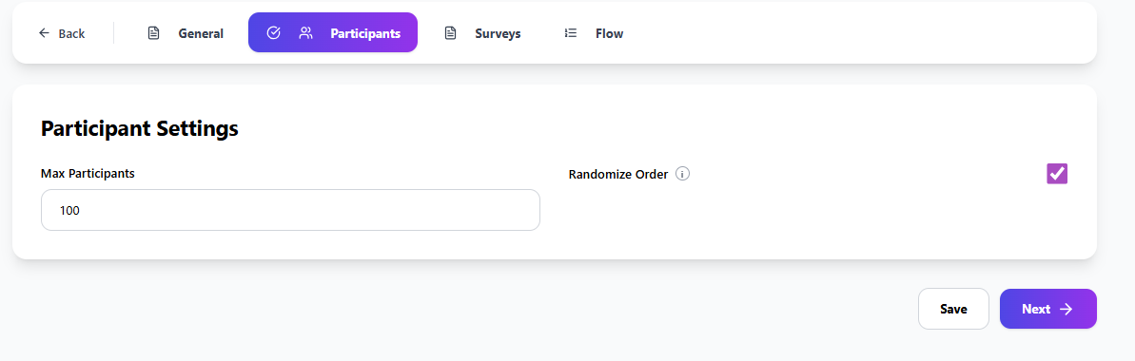
Enter the maximum number of participants (for example: 100). this sets the total number of users allowed to take part. Keep the Randomize Order checkbox selected, it randomly assigns each participant to one of your chatbot versions (A, B), which ensures a fair comparison and reduces bias.

  - Chatbot Experimentation (Surveys)

This is the Surveys section in Chatbot Experimentation where you add standardized questionnaires to collect user feedback after they finish interacting with the chatbot.

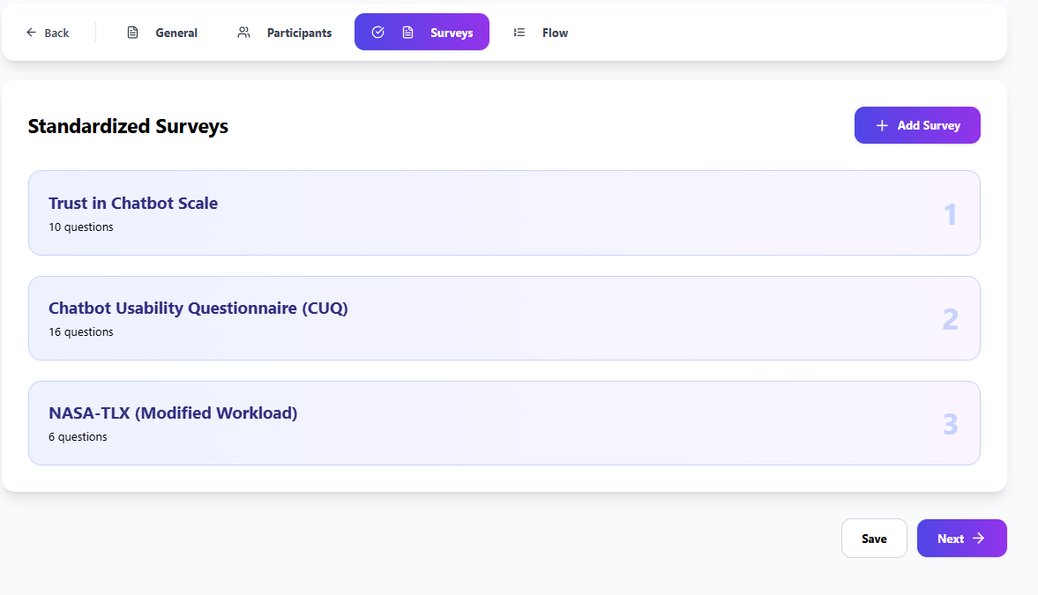

  - Chatbot Experimentation (Flow)
This is the Flow section in Chatbot Experimentation where you define the exact sequence of steps every participant will experience during the test. When everything is ready (General, Participants, Surveys, and Flow), click the purple Create Experiment → button at the bottom right. This saves the full setup and starts the experiment so real participants can join.

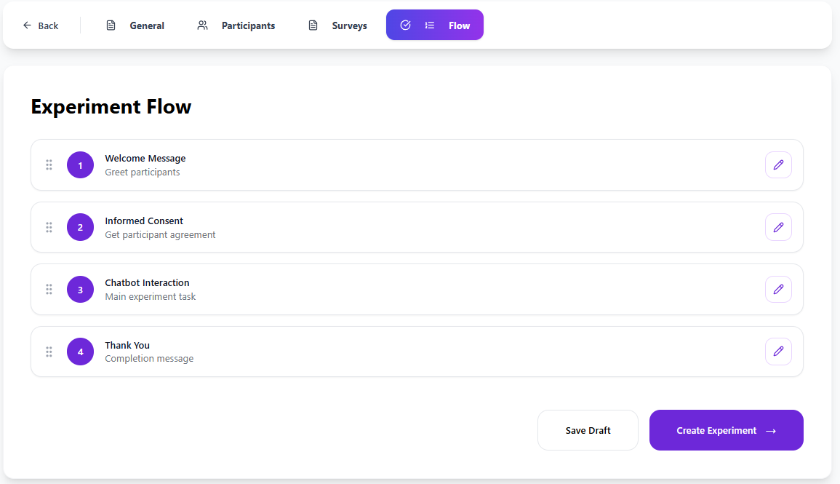

- Chatbot Editor (Template)
This is the Chatbot Editor Interface, the place where you fully customize your chatbot. the Template section is where you choose a starting point for your chatbot. Select one of the templates below to quickly get a pre-configured chatbot settings.

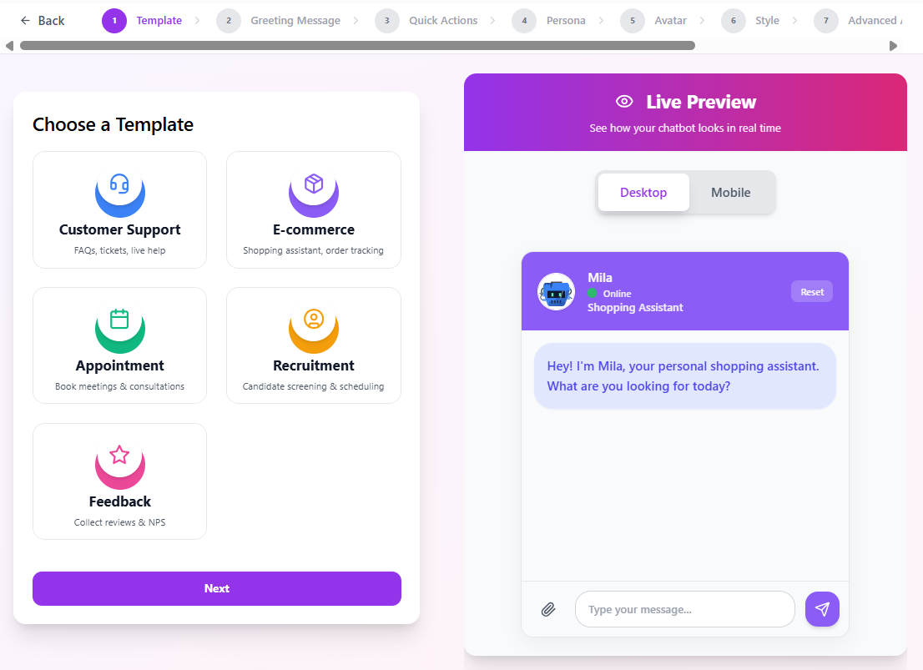
  - Chatbot Editor (Greeting Message)
This is the Greeting Message section in Chatbot Editor where you write the very first message your chatbot sends when someone starts a conversation.

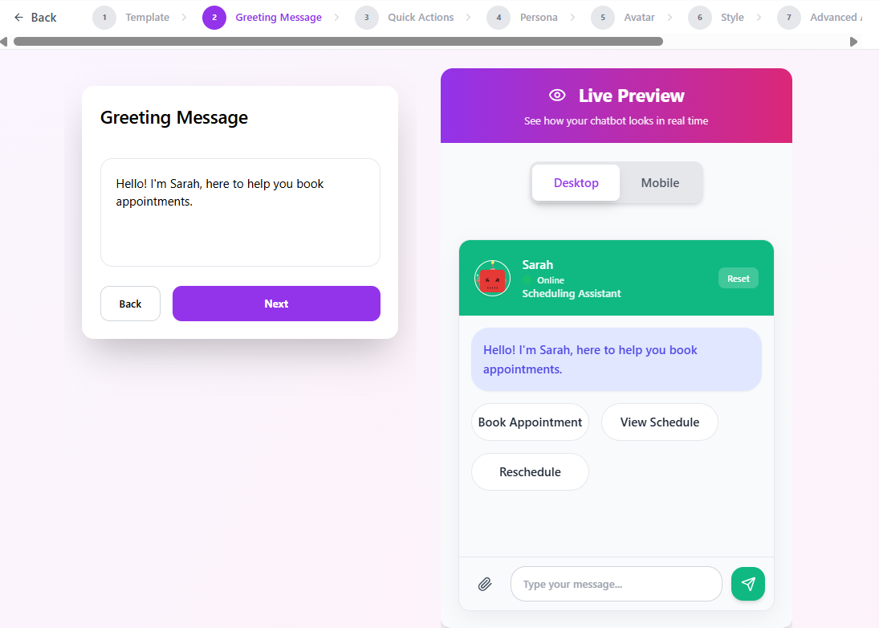

  - Chatbot Editor (Quick Actions)

This is the Quick Actions section in Chatbot Editor where you customize the Quick Action buttons users see when they first open the chat. These buttons help users start the conversation quickly instead of typing everything.
What you can do here:
- Edit the text on each button (e.g., change "Book Appointment" to "Schedule Appointment")
- Choose an icon for each button from the dropdown

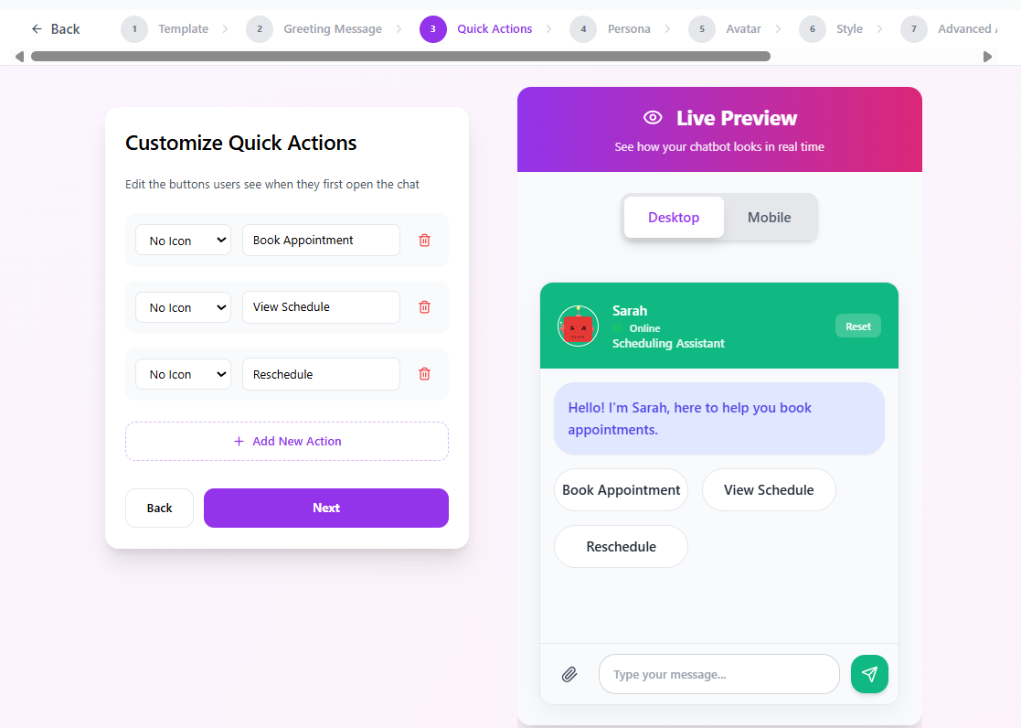

2.3) Chatbot Editor (Avatar Section)
This is the Avatar section in Chatbot Editor where you choose or upload the visual identity (profile picture/icon) for your chatbot.
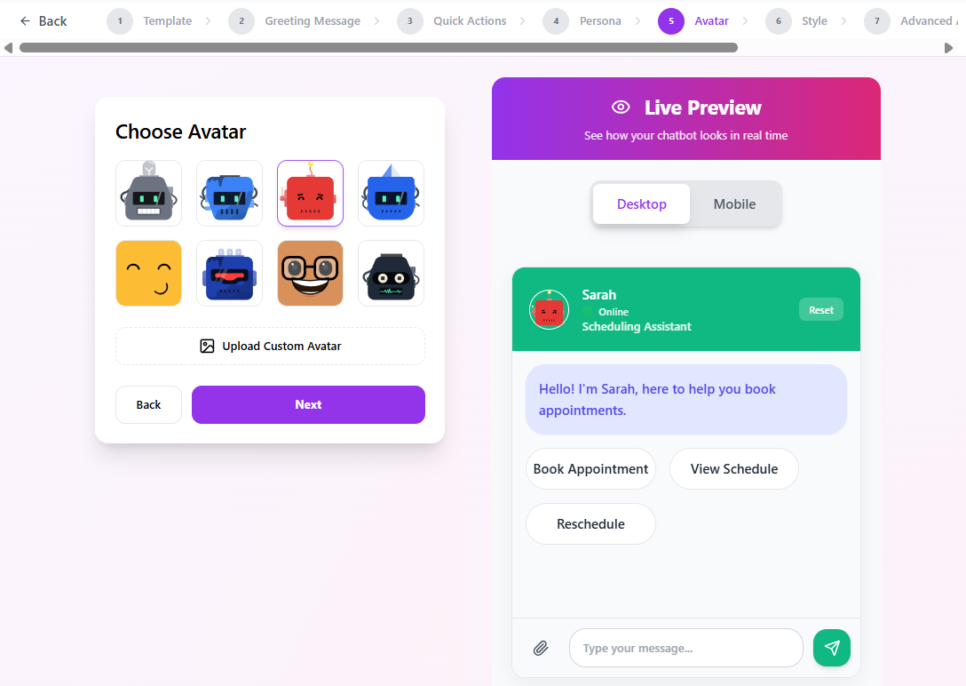
2.4) Chatbot Editor (Style)
This is the Style section in Chatbot Editor where you control the visual appearance of your chatbot. Here you fine-tune colors, shapes, shadows, and corner roundness so the chat looks exactly how you want it.
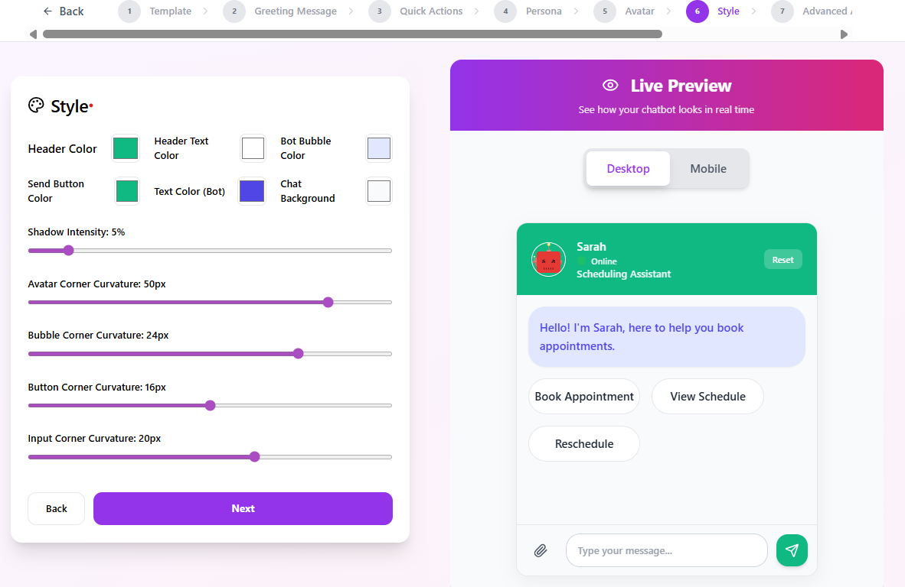

2.4) Chatbot Editor (Advanced Appearance)
This is the Advanced Appearance section in Chatbot Editor where you fine-tune extra visual and interaction details.
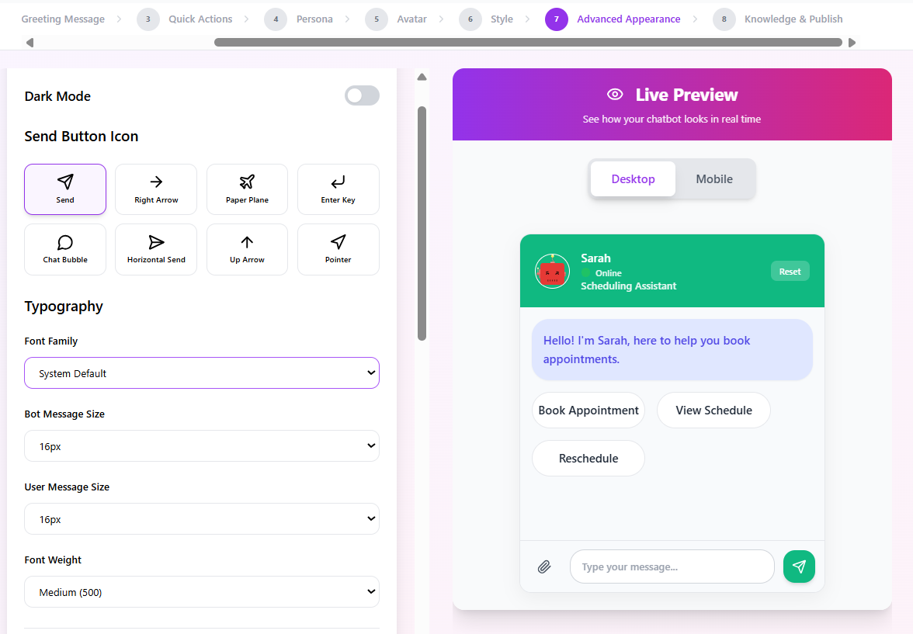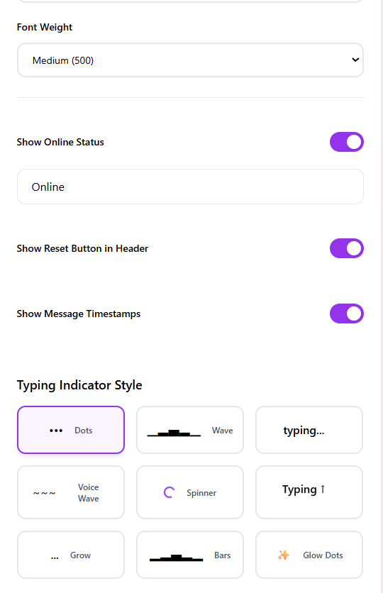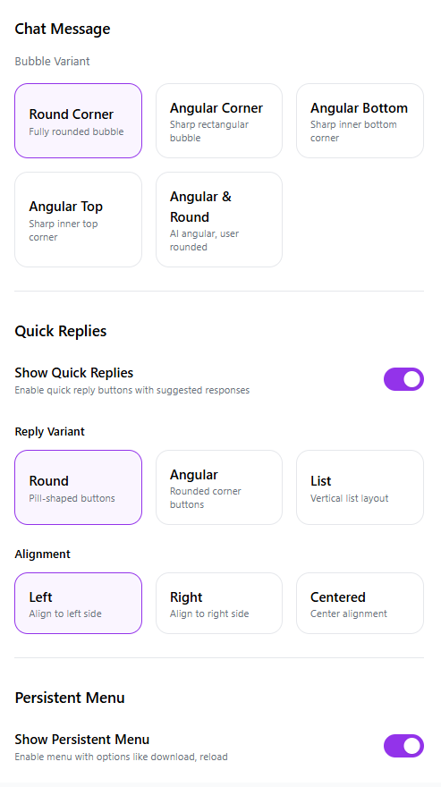

Toggle Dark Mode, choose a Send Button Icon (Send, Right Arrow, Paper Plane, Up Arrow, etc.), set Typography (Font Family, Bot/User Message Size, Font Weight), enable Show Online Status, show/hide Reset Button and Message Timestamps and select Typing Indicator Style (Dots, Wave, Spinner, etc.)

2.5) Knowledge & Publish
This is the Knowledge & Publish section in Chatbot Editor. the final step where you can save your changes and make the chatbot available. Click Save & Finish to save everything permanently. If you click Test Public Chat, it will redirect you to a new page where you can interact with the chatbot and see all your current changes applied in real time.

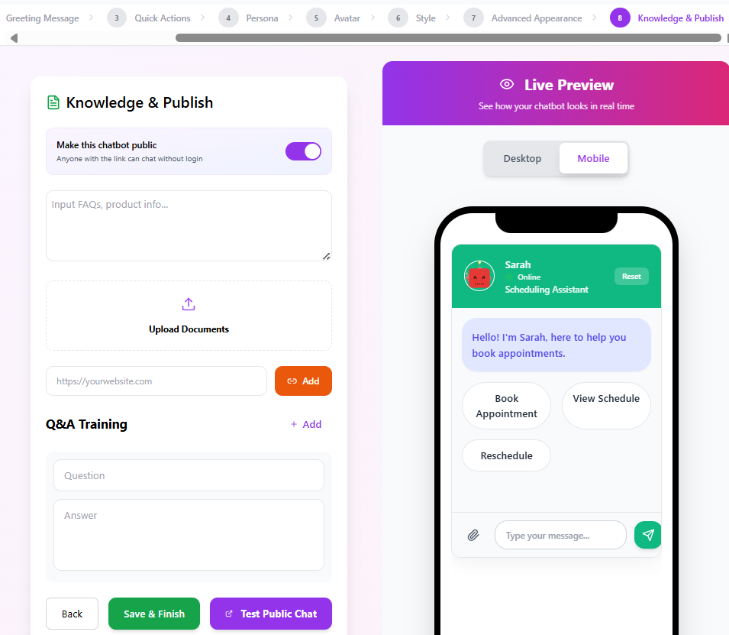

3) Dashboard
This is the Dashboard — your main overview page where you see a quick summary of your overall activity. It shows Total Participants (total users across all experiments), Completion Rate (percentage of conversations fully completed), Active Experiments (currently running tests), and Inactive Experiments (paused or finished ones). The Quick Actions card lets you jump to Your Experiments to view and manage all tests in detail, while Participant Demographics displays basic user info once surveys collect responses (currently showing none). Use the Export Data button at the top right to download all results for reports or analysis
